**D2 – Explain and justify improvements that could be made to a computer system**

**Introduction**

In this report, I will be explaining and justifying improvements that I made on M3. I will be explaining the following structure of this report:

* Identify any hardware/software components that may need to be upgraded or replaced; include a hyperlink to the components you select
* Demonstrate that the components will be compatible with each other. (E.g. correct RAM type, speed etc., CPU socket and/or MB expansion buses, power requirements)
* Identify the costs and potential benefits for now and future for each upgrade
* Justify how each component will assist to increase the performance of the system. Explain why the improvements are necessary

**COMPONENTS OF THE LAPTOP**

**RAM: 4GB**

**HARDWARE: 1TB**

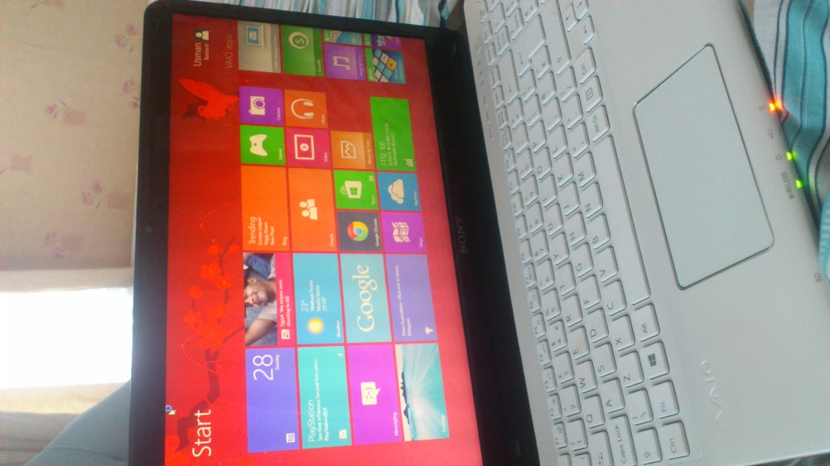**OPERATING SYSTEM: Windows 8.1**

**PROCESSOR: Intel Core i3**

**GRAPHICS CARD: Intel ® HD Graphics 4000**

These are the current components that have been installed in the laptop for it to work. They have not been changed nor new. I got this and these components just the way they are right now.

**IMPROVEMENTS OF THE LAPTOP**

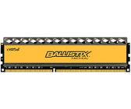The first upgrade that I suggest for this laptop is the **RAM**. The only advantage for once it has been increased is that the computer will run smooth and better than before. The benefits of increasing my RAM is that the user multitask by simultaneously open applications quicker. This could prevent any programmes that are open from slowing down or instantly being crashed. As the result of the RAM being 4GB, increasing it to 6GB would result in any heavy work that any user needs to do; the response of it would be better to deal with the heavy work. In addition, for future references, the user would need it. For example, if I were to go into the gaming industry, I would need a laptop with better specs then the one I got currently. Gaming involves heavy multitasking and handling with memory a lot, to deal with that on a laptop, the user needs to go for from 4GB to 8GB to deal with the gaming work. However, cost is everything to deal with and the user needs to consider the drawbacks of changing it from 4GB to 8GB. It costs around £400 to increase it. This is the picture of the RAM that I want it to be replaced with. It costs around £80, but the additional money comes in is that the user needs to install it.

**Crucial Ballistix Tactical 8GB DDR3 PC3-12800**

<http://www.idealo.co.uk/compare/4097793/crucial-ballistix-tactical-8gb-ddr3-pc3-12800.html>

A **processor** is a microchip imbedded into the CPU’s hard drive that manages all the programmes. It is known as the, “brains of the computer”. The processor’s job is that it holds instructions, which is given to the programmers. They are different types of processors, INTEL and AMD. For example, INTEL has different types such as Intel i3, i5, i7. Intel i7 has four cores. The second improvement that I am going to make on this laptop is the processor. As it is the “brains of the computer”, the brain needs to be efficient and working all the time. This is important for the processor to the latest version of it as possible, because if that is not, it can become slow and it can slow the performance of the computer. The one that I suggest for it to the Intel i7. The benefit of upgrading this is the speed of the computer. This is different to RAM as that controls the multitasking of the computer. The processor is the brain of it. This needs to be fast and once it is fast, it will produce a fast outcome with it. The cost of this is that it will be very complex to upgrade. As this is a laptop, it has a complex structure and it will take time to change the processor. It is not as simple as a computer because that it all separate. The laptop is together which contains many screws and it is small, so the user needs to be careful. In addition, cost with it is around £300 to purchase and on top, a professional completes this task to do it. The user needs to pay him to change it as well.

# Intel i7-920 (Bloomfield) Quad Core Processor

<http://www.amazon.co.uk/Intel-i7-920-Bloomfield-Quad-Processor/dp/B001H5T7LK>

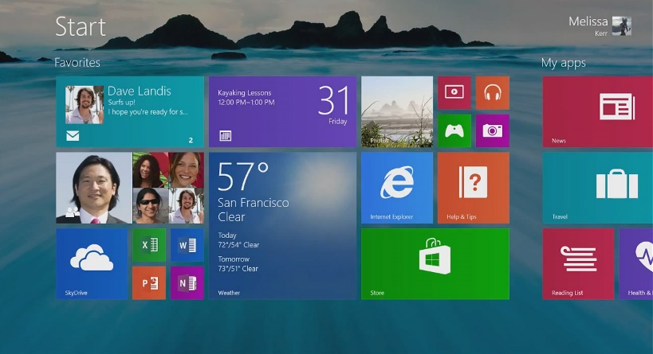Windows 8.1 is the latest on this laptop. They will be no upgrade on it as this is the latest Windows that there is out. However, it is important that the user pick up the **operating system** that he wants to use. I like to use Windows and it influences the performance by how it runs. Windows 8.1 is fast and in future, if any new Windows is released, I suggest he gets it. New and upgraded Windows is always faster and efficient. Comparing Windows 8.1 to Windows XP is a big difference with speed and efficiency.

The **hardware** is 1TB. One terabyte is a lot and any user can save a lot on this laptop. The steps of it to become 1TB is from 1KB to 1MB to 1GB and then 1TB. As you can see, it is a lot of stages to reach to that point. To upgrade this, it is not necessary at the moment. If at any stage it gets full, I recommend get an external device or added storage to fill save the document e.g. USB, external hard drives. The disadvantage of using external storage is that it can either get lost or the USB can get corrupted. It is important that the user safety removes the USB to prevent this from happening.

Each of the components that I have recommended will help the performance of the system as it will run faster and more efficient than the current specs. It is important for any person to have a computer that is fast. Nobody wants a slow computer. Increasing the RAM and processor will certainly help with more tabs/programmes multitasking, and the speed of the computer will raise for the processor. I have the new operating system and I highly recommend the new one. This is because if I compare the features of Windows 7 and Windows 8.1, it is very different. It is much faster and easier to handle, especially for new users. The hardware is the difficult one for this computer. It already has 1TB within the system and I feel that it does not need any more for it to upgrade. Obviously, if it runs out, it most certainly needs one with extended storage devices.

Other devices within the performance of the system can help the user by scanning the computer fully each day, cleaning out the waste, unwanted files and removing any files that the user does not need e.g. pictures and defragmentation. These acts help the performance of the computer by getting rid of files that is not necessary. If they are loads of files that are not deleted, it will slow the performance down. To improve the performance, these daily routines need to be acted upon each day to be complete.